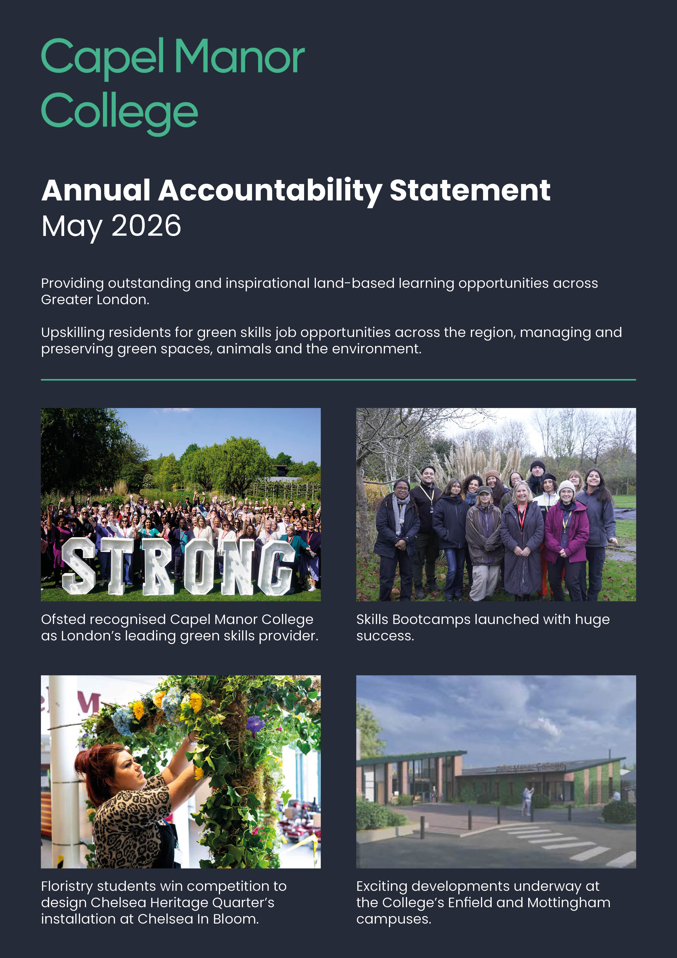

July 2026

Providing high quality and inspirational land-based learning opportunities across Greater London.
Upskilling residents for green skills job opportunities across the region, managing and preserving green spaces, animals and the environment.


Providing outstanding and inspirational land-based learning opportunities across the Greater London region

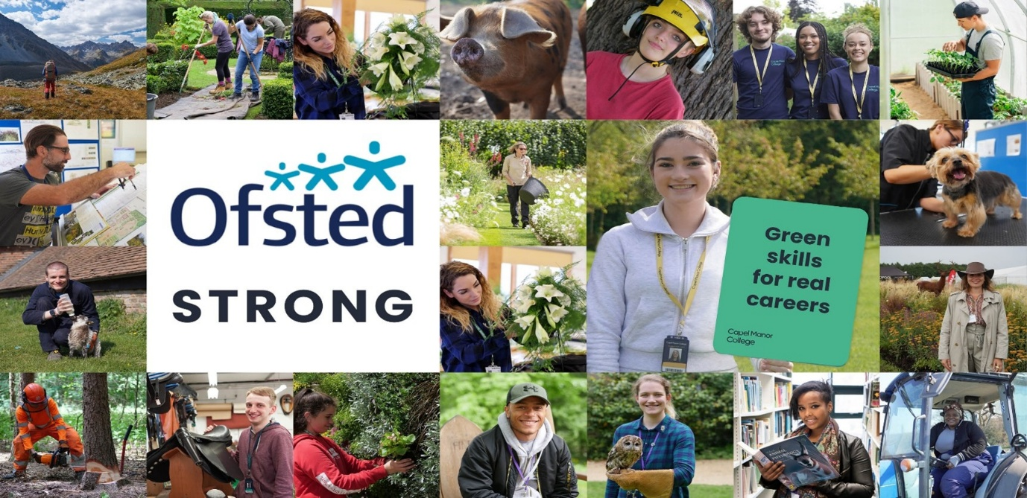

Contents
1. Executive Summary & Key Development Priorities 3
2. Overview of the College: 7
2.1 Our Mission: 7
2.2 Our Vision: 8
2.3 Our Values 8
2.4 Our Strategic Objectives: 9
2.5 Context and Place 9
2.6 Education Levels and Insights by Campus and Borough 11
3. Approach to Developing This Statement & Contributions to Those We Serve: 13
3.1 Strategic Positioning 14
3.2 Employer Engagement Contribution 15
3.3 Educational Partnerships Contribution 17
3.4 Civic Contribution 19

4. Conclusion and Strategic Outlook 20
5. Corporation Statement 22

Appendix i: The EIF Standards for the Contribution to Skills Needs 23
Appendix ii: Current Position 2025-26 24
References & Relevant Links 30

- Executive Summary & Key Development Priorities

Capel Manor College is London’s only specialist environmental and land-based college, playing a leading role in addressing the capital’s green skills priorities. Through extensive and purposeful engagement with employers, civic partners, sector bodies, and regional skills networks, the College has established itself as a recognised, strong leader within London’s green skills ecosystem.
College leaders work collaboratively with the London Strategic Skills Provider Network, Local Skills Improvement Plan (LSIP) partners, the Greater London Authority, employers, local authorities, and industry stakeholders to ensure that the curriculum remains highly responsive to local, regional, and national workforce priorities. This strategic alignment enables the College to contribute directly to London’s ambitions around sustainability, biodiversity, climate resilience, and the transition to a greener economy.
College leaders use detailed labour market intelligence and sector insight to shape curriculum planning and curriculum content effectively. Employers and stakeholders actively co-design curriculum pathways, contribute to live projects, provide industry-standard experiences, and support work-based learning opportunities. As a result, learners and apprentices develop current technical skills, professional behaviours, and sector-specific knowledge that align closely with emerging workforce needs across the green economy.
At subject level, curriculum content is continuously reviewed and refined to reflect developments in sustainability, biodiversity management, conservation practice, and environmental technologies. Curriculum areas such as saddlery, horticulture, floristry, animal management, arboriculture, conservation, and environmental sustainability provide learners with relevant industry knowledge and practical experience that prepare them well for employment, apprenticeships and future study.
Apprenticeship provision is developed collaboratively with employers to ensure strong alignment between on- and off-the-job training. Employers contribute directly to curriculum design, technical training, and industry practice, enabling apprentices to develop the skills, behaviours, and knowledge required within their sectors.
College leaders have established strong and sustainable partnerships with major employers, community organisations, local authorities, and sector bodies. These partnerships provide learners and apprentices with access to high-quality work placements, industry projects, apprenticeships and progression opportunities across London’s environmental and land-based sectors. Learners frequently apply their skills within industry-leading environments and make meaningful contributions to environmental sustainability and community-based projects across the capital.
The College’s strong civic contribution and employer engagement ensure that learners and apprentices are exceptionally well prepared for progression into employment, apprenticeships, higher education and careers within the green economy. Capel Manor College is widely recognised as a key institution supporting the development of London’s future green workforce while contributing positively to both economic growth and environmental sustainability.
Ofsted (January 2026) assessed the College’s contribution to meeting skills needs as ‘Strong’, reflecting the following headline strengths:
- Strong strategic engagement with employers, civic partners, LSIP stakeholders, and sector bodies to shape a highly responsive green skills curriculum.
- Recognised regional leadership in environmental and land-based education across London and the surrounding region.
- Curriculum planning informed by detailed labour market intelligence and emerging workforce priorities.
- Extensive employer co-design of curriculum content, live projects, work placements, and apprenticeship pathways.
- High-quality industry partnerships providing learners with access to professional environments and meaningful progression opportunities.
- Strong alignment between apprenticeship training and employer workforce needs.
- Learners and apprentices develop up-to-date technical skills, sustainability knowledge, and professional behaviours relevant to the green economy.
- Significant contribution to London’s environmental sustainability agenda through conservation, biodiversity, horticulture, and urban greening initiatives.
- Inclusive curriculum pathways supporting learners from diverse and disadvantaged backgrounds into green sector careers.
- Increasing strategic influence across London’s wider green skills and environmental sustainability agenda.
College leaders are building on the College’s strong contribution to skills by further embedding sector-leading practice, deepening employer and civic partnerships and extending the College’s strategic influence across London’s green skills ecosystem. The College remains committed to ensuring that curriculum planning, teaching and industry engagement continue to evolve in response to emerging workforce priorities, sustainability challenges and developments within the environmental and land-based sectors.

Through sustained collaboration with employers, sector bodies, local authorities, and regional skills networks, the College is well positioned to strengthen its role as a leading contributor to London’s green economy. College leaders will further enhance the measurable impact of employer engagement, learner progression, civic contribution and environmental sustainability initiatives to ensure that learners and apprentices are exceptionally well prepared for employment, independence and future study.
The College’s ongoing focus is to refine and strengthen existing areas of excellence through curriculum innovation, subject-level industry integration, and system leadership across the wider further education and skills sector.
Leaders will also strengthen the College’s contribution to wider sector improvement through active engagement with professional networks, employer forums, LSIP partnerships, and regional green skills initiatives. The College will further develop its role in sharing effective practice across the further education and skills sector, supporting collaboration, innovation, and workforce development across London’s environmental and land-based industries.
The College is ambitious for its students, the work it undertakes on behalf of employers, partners and stakeholders and remains keen to build further upon the ‘Strong’ position described by Ofsted, enabling further expansion of these upskilling and progression opportunities to benefit even more Londoners and communities.
As a result, the following areas provide a focus for further development over the next year:
Key Areas for Development 2026 - 2027 | Contribution towards National, Regional and Local Priorities
1.Establish Capel Manor College as a National Green Skills Centre of Excellence by 2027 via:  - Embedding the ethos of employer-centric, co-creation of skills provision across all curriculum areas via the Employer Skills Hub.  - Strengthening strategic partnerships with key sector bodies and employers, including the sharing of sector-specific expertise, research, insight and recruitment support.  - Moving the College from ‘Strong’ towards ‘Exceptional’ standard on the Ofsted assessment scale for contribution to meeting skills needs.  - Achievement of sector-leading outcomes & achievement rates for ‘Made at Capel’ student practitioners across all green skills programmes.  - The achievement of carbon neutrality across all campuses by 2030, supported by a clear, measurable sustainability action plan aligned with national and London-wide climate goals. | Collaborate with government and industry to establish the College as a leading training hub for green careers; meeting regional and local skills needs through delivery of national priority programmes.  Enable our students to succeed in their chosen technical and vocational programme; contribute to meeting the skills needs of London and the employment sectors comprising the wider land-based sector.  Ensuring Capel students leave with the qualifications, experience and confidence needed to succeed in green careers and contribute meaningfully to London’s environmental and economic future.  Aligning with the Government priorities to deliver a net zero future.
2. Deliver the 2026–27 curriculum development strategy by:  - Expanding ‘green skills’ adult programmes, apprenticeships, and T-Level options across London.  - Creating inclusive, multi-skills pathways into green careers for Year 10–11 students, NEETs, post-16, and adult learners, including Supported Internships.  - Provide specialist support to maximise student achievement of Level 2 English and maths in line with DfE ‘Effective Practice’ and ‘Condition of Funding’ guidance.  - Increasing the number of professional short courses and ‘license to practice’ awards.  - Expanding bespoke green Skills Bootcamps provision.  - Promoting access and inclusion and flexibility by extending the College’s online learning offer.  - Conducting a strategic review of Higher Education delivery to align all curriculum, models and partnerships with the College’s long-term strategic goals.  - Developing transition plans to support effective preparation for implementation of the SEND reforms. | Develop more pathways which secure improved progression and positive outcomes, enabling more young people and adults to develop the skills needed by employers across the London region.  Aligning adult education and skills provision with the London Growth Plan, Inclusive Talent Strategy and LSIP by delivering inclusive talent development, green skills, and employer-responsive pathways.  Develop additional curriculum offers that promote greater awareness/uptake of green skills programmes by more Londoners.  Increased contributions to reducing unemployment and promoting social mobility with education open to all regardless of background or prior qualifications.  Support and strengthen the importance of progression to higher level learning.  Ensuring Capel students leave with the qualifications, experience and confidence needed to succeed in green careers and contribute meaningfully to London’s environmental and economic future.
3. Develop inspirational ‘state-of-the-art’ delivery capabilities across all London campuses via capital investment programmes which;  - create enhanced facilities and modern, inclusive environments  - inspire both existing and new students to pursue upskilling opportunities  - support industry-relevant training  - promote recruitment, wellbeing and retention of expert staff  - ensure Capel remains at the forefront of green skills education in London. | Improved specialist resources to support expansion of curriculum delivery in priority sectors.  Inspirational facilities to attract new students from deprived communities.  More young people and adults will gain the skills they need to improve their job prospects and succeed in priority sectors, whilst supporting the economy.

- Overview of the College:
As London accelerates its commitment to a greener, more inclusive, and economically resilient future, the role of education providers in addressing skills gaps has never been more critical. Capel Manor College stands at the forefront of this agenda as London’s only specialist environmental and land-based college. With campuses embedded across the city and a curriculum rooted in sustainability, biodiversity, and the natural environment, Capel Manor College plays a pivotal role as a conduit between education, employment, and community growth.

Our Mission: To Support the Environment and Green Skills in London

We are proud to be a diverse, inclusive, and community-focused college where every student and member of staff is supported to achieve their full potential. Through inspirational teaching, industry-relevant learning, and a strong culture of support, we prepare learners with the skills, confidence, and ambition to thrive in the green economy.
Our curriculum is shaped by the needs of employers, communities, and the environment, ensuring our learners are ready to make a positive impact across London and beyond. We are committed to creating opportunities, raising aspirations and delivering exceptional support for both students and staff in a culture where people feel valued, empowered, and inspired to succeed.

Our Vision: An environmentally, economically and socially sustainable future for our students

We believe education should do more than lead to qualifications. We aim to transform lives by providing opportunities that build confidence, develop skills, raise aspirations, and improve prospects. Through high-quality learning, strong industry connections, and a supportive college community, we empower students to succeed in employment, further study, and life.
We want to be the college of choice for learners seeking not only career opportunities, but also personal growth, purpose, and the skills to contribute positively to a more sustainable future.

Our Values

Aspirational - We proactively and continuously seek the best from ourselves and each other through ambition, perseverance and resilience.
Responsible - We care about the environment, animals and people, promoting harmony, respect and sustainability.
Fair - We value individuals and our community, promoting diversity through inclusiveness, equality, openness and mutual respect.
Creative - We encourage passion, creativity, innovation and enterprise to enrich vocational and personal development.
Professional - We encourage behaviours and standards that inspire personal and professional achievement.
Listening - We listen to employers, our sectors and each other, and act on feedback.

Our Strategic Objectives:

Deliver outstanding learning experiences for our students | We are committed to providing every student with an exceptional education, one that offers a coherent and challenging curriculum, equipping them with the knowledge, skills and ambition to thrive in their future learning, careers, and personal lives.  We will proactively encourage and nurture students to develop the attitudes and behaviours they need to succeed, preparing them to be confident professionals in the workplace and active contributors to society.  We place student voices, employer input, and customer satisfaction at the heart of our service delivery. By fostering a culture of accountability, continuous improvement, and innovation, we will continually enhance all aspects of our customers’ experience.
Develop, reward and retain excellence via an enhanced people proposition | We will build an outstanding people proposition that attracts, develops, and retains exceptional talent.  Through tailored professional development, recognition schemes, and clear pathways for progression, we will empower our people to grow, thrive, and lead within our organisation.  We will create a culture where excellence is celebrated, individuals feel valued and supported, and teams are inspired to achieve their full potential. By investing in our people, we will drive continuous improvement, innovation, and high performance at every level.
Secure increased financial sustainability, enabling reinvestment in people, facilities and new capabilities | We will strengthen our financial sustainability, enabling reinvestment in our people, facilities, and new capabilities.  Through robust financial management, strategic growth, and effective resource allocation, we will ensure long-term stability and the capacity to innovate and expand.  By maintaining a disciplined approach to cost control and exploring new income streams, we will create a resilient financial foundation that supports our ambition for excellence and growth.
Refresh our curriculum offer, ensuring a strong voice for employers and other  commissioners/stakeholders which reflect local, regional and national skills needs. | We will refresh and future-proof our curriculum offer, ensuring it  continually reflects the latest local, regional, and national skills  priorities.  We will collaborate closely with employers, stakeholders, and commissioners to shape a responsive and ambitious curriculum that prepares students for the evolving world of work.

Context and Place
Capel Manor College holds a unique and vital position within the Further Education and land-based sectors. For over 56 years, the College has been at the forefront of land-based education, training thousands of students for careers in horticulture, landscaping, garden design, agriculture, conservation, animal management, arboriculture, forestry, floristry, event styling and saddlery & shoemaking. This breadth of provision positions Capel as a leader in preserving specialist skills that are critical to the UK’s green economy, creative industries, and high-value manufacturing sectors.
Capel Manor is the only college in Europe offering full-time Saddlery training, a programme delivered at the Enfield campus and supported by the Worshipful Livery Companies and royal patronage. This unique course safeguards and advances traditional leatherworking skills including saddle, bridle, and harness making ensuring the continuation of crafts essential to the UK’s cultural heritage and economy. Graduates progress into specialist industries, working with Master Saddlers, luxury brands, the equine sector, the British Army, and the creative industries, including fashion, theatre, and film.
Capel Manor’s impact extends beyond its curriculum. The College works with over 200 employer partners, industry leaders, and alumni to co-design programmes, offer work placements and shape clear progression pathways into employment and further study. As a founding member of the Mayor’s Green Skills Academies and a key partner in the London Green Space Skills Hub and Local Skills Improvement Plan (LSIP), Capel plays a system leadership role in shaping London’s green skills agenda and addressing the city’s current and future workforce needs.
There are six main academic areas within the College provision:
- Apprenticeships and Business Development
- The Princess Royal College of Animal Management and Saddlery
- The School of Arboriculture, Agriculture and Environmental Conservation
- The School of Floristry and Event Styling
- The School of Foundation Learning
- The School of Horticulture, Landscaping and Garden Design
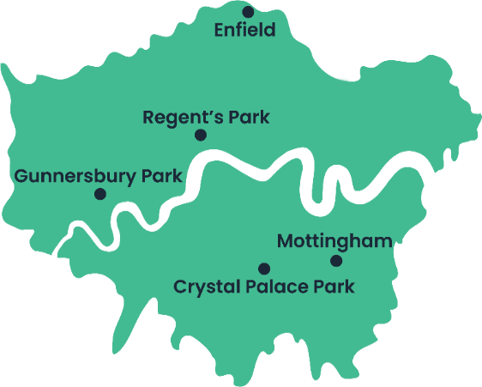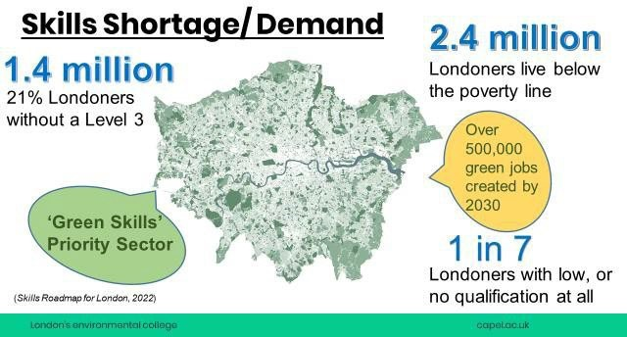
Operating across five campuses, Capel Manor College delivers an inclusive, city-wide land-based curriculum designed to meet the diverse needs of London’s communities. Through employer-led design, the College offers accessible pathways into land-based employment, supporting social mobility and community progression. As London’s only specialist land-based college, Capel Manor is uniquely positioned to address the skills needs identified in the Mayor’s Skills for Londoners Strategy and by the city’s land-based employers.

Education Levels and Insights by Campus and Borough
Educational attainment data across the boroughs served by Capel Manor College highlights a clear need for targeted skills provision. In areas such as Enfield and Greenwich, a significant proportion of adults lack formal qualifications, whilst 16–18-year-olds underperform relative to the London average. Capel Manor’s specialist vocational pathways in land-based and green skills directly address these gaps, creating accessible progression routes into the workforce and higher-level study.
By focusing on skills for sustainability, green economy growth and community resilience, Capel Manor aligns with national priorities for upskilling, reskilling, and lifelong learning. The College acts as a vital conduit between education, industry, and community improving access to high-quality technical education and delivering the green skills London needs for a fairer, more inclusive future.
Educational attainment across the boroughs served by Capel Manor College varies significantly. In Enfield, 22.5% of residents aged 16 and over hold no formal qualifications, compared with 16.2% across London and 18.1% nationally. Conversely, 36.3% hold qualifications at Level 4 or above — higher than the national average, but significantly below the London average. This polarised attainment profile highlights ongoing challenges relating to social mobility, skills inequality and adult participation in learning.
Ealing and Bromley, home to the College’s Gunnersbury Park and Crystal Palace campuses, show stronger educational attainment profiles, with approximately 14–15% of residents holding no formal qualifications, below the national average. Around 43–44% of residents hold qualifications at Level 4 or above, reflecting relatively high skills attainment, although still below some of London’s highest-performing boroughs. This highlights continuing challenges in supporting progression to higher-level skills across all communities.
Camden, home to the College’s Regent’s Park campus, demonstrates one of the strongest educational attainment profiles in London. Only around 11.8% of residents hold no formal qualifications, while approximately 60.4% hold qualifications at Level 4 or above, significantly exceeding both London and national averages. This reflects strong progression into higher education and professional employment, alongside high levels of economic participation and skills attainment.
Greenwich, served by the College’s Mottingham campus, has a slightly higher proportion of residents with no formal qualifications than the London average, although still below the national figure. Around 45–46% of residents hold qualifications at Level 4 or above, broadly reflecting the wider London skills profile. However, challenges remain in supporting adults with lower prior attainment to engage in education, develop skills, and progress into sustainable employment.
These insights reinforce the vital role of Capel Manor College in addressing skills gaps, widening participation, and supporting progression into higher-level learning and employment, particularly for young people and adults from underrepresented and lower-attaining backgrounds.
London’s educational landscape is one of significant contrasts; a globally competitive, high-performing economy alongside persistent inequality, disadvantage, and social exclusion. In this context, Capel Manor College plays a critical role in providing inclusive, employer-informed, land-based education that supports social mobility, develops confidence and aspiration, and prepares learners for meaningful careers.
Through its specialist green skills and land-based curriculum, the College provides an important alternative pathway for learners to gain technical expertise, achieve recognised qualifications and progress into careers across sustainability, conservation, horticulture, animal management, arboriculture, and environmental industries. In doing so, the College is helping to bridge the gap between lower prior attainment, and the advanced green skills London urgently needs to support a sustainable future.
Capel’s work is aligned with regional and national priorities, from the Green Jobs Delivery Plan and London Green Skills Hub to the expansion of T-levels, Skills Bootcamps and inclusive provision such as Supported Internships. Based on the 2021 Census data from the Office for National Statistics (ONS), the table below highlights the breakdown of educational attainment in the London boroughs served by Capel Manor College:
Borough | Campus | % with  No Quals (2021 Census) | National Average England No Quals | London Average  No Quals | % with Level 4 or Above  (2021 Census) | National Average England  Level 4 or above | London Average  Level 4 or above
Enfield | Enfield | 22.5% | 18.1% | 16.2% | 36.3% | 33.9% | 48.0%
Ealing | Gunnersbury Park | 14.9% | 18.1% | 16.2% | 44.3% | 33.9% | 48.0%
Bromley | Crystal Palace | 13.8% | 18.1% | 16.2% | 42.8% | 33.9% | 48.0%
Camden | Regent’s Park | 11.8% | 18.1% | 16.2% | 60.4% | 33.9% | 48.0%
Greenwich | Mottingham | 16.7% | 18.1% | 16.2% | 45.7% | 33.9% | 48.0%

- Approach to Developing This Statement & Contributions to Those We Serve:

Strategic Positioning

Capel Manor College is London’s only specialist environmental and land-based college, uniquely positioned to lead the capital’s green skills agenda and support the workforce needed to deliver London’s transition to a greener and more sustainable future. As such, the College plays a critical role in developing the technical, professional, and environmental skills required to address climate change, biodiversity loss, environmental sustainability and the transition to a net-zero economy.

The College’s curriculum is closely aligned to emerging national, regional and local priorities across further education, skills and workforce development. This includes the Government’s post-16 education and skills reforms, the strategic priorities of Skills England, Local Skills Improvement Plans (LSIPs), the Local Skills Improvement Fund (LSIF), the Mayor of London’s Green Skills Academy mission, and wider environmental sustainability and economic growth strategies. Through specialist provision in areas such as horticulture, arboriculture, conservation, animal management, landscaping, floristry, saddlery, and rewilding, the College supports the development of a highly skilled workforce capable of sustaining and improving London’s natural and built environments. The curriculum also reflects the evolving direction of travel within further education, including curriculum innovation, inclusive and flexible learning pathways, apprenticeship reform and the growing demand for technical and green skills across the wider economy.

Operating across five campuses and serving learners from all 32 London boroughs, the College is a significant civic, environmental and community anchor institution. It provides inclusive, accessible and community-focused education that supports social mobility, widening participation, progression into skilled employment, higher education and sustainable careers; the College undertakes significant schools-liaison and direct marketing activities in order to maximise learner reach and awareness of the programme opportunities on offer.

The College serves a highly diverse learner population, with a lower than average prior learning attainment (compared to other land-based colleges nationally) and over 91% of students presenting with some form of disadvantage or additional learning support need, including over 200 with EHCPs. The student cohort covers study at all levels, from Entry to HE and includes 14-16 year olds, young people direct from the school system, those who are NEET or who require a ‘second chance’ learning opportunity having initially studied elsewhere, adults returning to education, career-changers looking to upskill, those in employment or setting up their own businesses requiring further ‘licence to practice’ provision and those wishing to progress into higher education.

Upon joining Capel a significant number of students have not managed to secure Level 2 English and maths qualifications critical to their future progression and employability prospects, with the College deploying specialist resources to help equip them with these skills.

Capel Manor College is also well positioned to respond to evolving national reforms across further education, including SEND and alternative provision reforms, curriculum innovation, and the future skills agenda. Through inclusive curriculum design, personalised support, and employer-informed pathways, the College provides flexible and accessible progression routes for learners with diverse needs and starting points, supporting engagement, wellbeing, achievement, and progression into sustainable employment and further learning.

As a founding member of the Mayor’s Green Skills Academies, a key contributor to the London LSIP and Local Skills Improvement Fund (LSIF) collaborations, and an active partner within the London Green Space Skills Hub, the College works collaboratively with employers, local authorities, sector bodies, and community organisations to co-design and deliver curriculum that responds directly to labour market need and environmental priorities.

Demand for green skills across London continues to grow rapidly, driven by climate adaptation, biodiversity targets, sustainable construction and environmental management priorities. Employers continue to report shortages in specialist technical skills across sectors including horticulture, landscaping, arboriculture, conservation, and animal care. Capel Manor College plays a vital role in addressing these workforce shortages through employer-informed curriculum planning, industry partnerships and practical technical education.

The College’s participation in the LSIF collaboration further strengthens its strategic impact across London’s skills system. Working alongside 23 delivery partners serving over 2.2 million Londoners across North, East, and Southeast London, the collaboration aims to expand access to high-quality green and digital skills provision through innovation, partnership working and digital technologies. Capel Manor College is the only London college with a curriculum specifically focused on restoring and sustaining London’s green spaces, reflecting its unique contribution to the capital’s environmental infrastructure and long-term sustainability ambitions.

Through practical land-based learning, environmental projects, and community engagement, learners contribute directly to biodiversity, conservation, urban greening, food sustainability and the stewardship of London’s natural environments. The College is increasingly recognised as a system leader within London’s green skills landscape, contributing to regional skills planning, sector collaboration and the development of innovative approaches to environmental and sustainability education.

In a city facing significant environmental, economic, and social challenges, Capel Manor College provides a distinctive and essential educational offer; equipping Londoners with the skills, confidence, resilience, and environmental awareness needed to succeed within a rapidly evolving green economy and contribute to a greener, fairer and more sustainable future.

Employer Engagement Contribution
Capel Manor College is a leading force in London’s green economy uniquely positioned as the capital’s only specialist land-based college, working with over 200 employers and industry leaders across horticulture, conservation, animal care, arboriculture, floristry, landscaping and environmental management, ensuring delivery of a curriculum which is employer-led.
Capel’s employer partnerships include a diverse range of organisations from The Royal Parks and Buckingham Palace, to The Zoological Society of London and The Royal Veterinary College, demonstrating the breadth and depth of industry engagement. For further examples of partners and project examples, please refer to Appendix ii. Our Strategic Employer Engagement framework provides a systematic, strategic approach to engagement, capturing live business intelligence, industry trends, and future skills needs through:
- Employer forums and advisory panels
- Work placements, site visits, and guest lectures
- Co-designed projects, live briefs, and real-world assessments
This intelligence directly informs our curriculum design, assessment strategies and delivery models, ensuring Capel Manor’s provision remains agile, responsive and future-focused. We align our curriculum to:
- Vector Labour Market Intelligence (LMI)
- Local Skills Improvement Plans (LSIPs)
- The Mayor’s Green Skills Strategy
- London Growth Plan
- London Inclusive Talent Strategy
This approach equips learners with the technical skills, behaviours, and mind-sets needed to thrive in a rapidly evolving labour market maximising their employability, adaptability and career progression.
Our partnerships with organisations such as Groundwork, Parks for London, borough councils, conservation charities and land-based businesses ensure our provision is deeply embedded in the real-world needs of London’s green economy. We work closely with employers to adapt delivery models, flexing timetables, modes of learning (in-person, remote, hybrid), and engagement strategies to meet specific sector needs ensuring learners access meaningful, industry-aligned education and skills training.
Capel Manor College plays a system leadership role in the regional skills ecosystem, supporting over 3,000 learners annually and contributing to a talent pipeline that strengthens London’s green and land-based industries.
Our provision directly supports:
- Employer growth and innovation, addressing emerging skills gaps
- The transition to a net zero economy through green skills development
- Social mobility and inclusion, enabling Londoners from all backgrounds to access high-value, future-focused careers
Capel Manor’s employer partnerships are not just about engagement, they are a strategic driver of curriculum innovation, economic resilience, and regional growth. Our collaborative model ensures learners graduate with the skills, confidence and professional behaviours employers need today and for the future.

Educational Partnerships Contribution
Capel Manor College is committed to playing a leading role in London’s education and skills system. We collaborate with schools, colleges, universities and sector bodies to ensure learners develop the knowledge, skills, and behaviours needed for progression into meaningful employment and further study. Our skills contribution through educational partnerships includes:
Landex – Land-Based Colleges Aspiring for Excellence. Capel Manor is a full member of Landex, the UK-wide network of specialist land-based colleges. This provides a framework for sector-wide collaboration, quality improvement and benchmarking. We participate in the annual Peer Review process, supporting continuous improvement in curriculum quality, teaching, learning, and assessment. We share best practice, co-create sector standards, and influence national policy to ensure Capel’s provision is aligned with national priorities and industry needs.
Universities and Higher Education Institutions. Capel Manor College continues to strengthen progression opportunities for learners across the land-based and environmental sectors, creating clear pathways from Further Education into Higher Education, specialist training and skilled employment. Partnerships with Royal Agricultural University and Royal Veterinary College support collaborative curriculum development and progression routes in areas including Animal Management, Veterinary Nursing and Conservation, while also enabling access to specialist expertise and industry-informed learning.
The College also works collaboratively with university and sector partners to co-design distinctive specialist provision, including the bespoke Shoemaking programme. In addition, early discussions are underway with Royal Horticultural Society to explore the development of higher-level Horticulture and Rural Enterprise pathways, further strengthening opportunities for learners to progress into advanced study and professional careers within the business and green economy.
Schools and Progression Pathways. Active engagement with schools across all 32 London boroughs, offering taster days, school visits and progression pathways into land-based courses widening participation and inspiring young people to pursue green careers. Capel has expanded the number of young people enrolling on its courses via the development of a Schools Liaison Framework, including a tiered engagement model, targeting areas of deprivation and underrepresentation.
Local Authorities and Civic Partners. Close collaboration with Enfield Council through the Delivering Better Value (DBV) programme to improve outcomes for learners with SEND. Partnerships with borough councils to deliver community projects in conservation, rewilding and therapeutic horticulture, providing learners with meaningful, real-world civic experiences.
FE Sector Collaboration. Active member of Green Skills Hubs (West London, Green Space Skills, Local London), helping shape regional strategy and share best practice across the sector. Participation in regional curriculum networks (e.g., Animal Management Advisory Board with East Kent College) to share insights on industry trends, curriculum innovation, and sector standards.
Industry-Integrated Learning. Co-created curriculum and employer-led assessments embed learning in real-world industry contexts. Examples include the Worshipful Livery Companies involvement in Saddlery and Shoemaking training and many employers contributing to assessments, project evaluations and learner mentoring
Inclusive Access Initiatives. Working with specialist schools, local authorities, and community organisations to widen participation for learners from underrepresented backgrounds, including ethnic minority groups, learners from areas of deprivation and those with High Needs. Providing specialist support services and inclusive learning environments that enable all learners to thrive. Working with alumni of the College to provide case studies and support which inspires engagement.
Skills System Leadership. Collaborative partner in Local Skills Improvement Plans (LSIPs) and the Mayor’s Skills Strategy, shaping the future of education and skills provision in London. Delivery partner for T Levels, HTQs, LSIF, and Green Skills Bootcamps, ensuring learners access cutting-edge skills for the future economy.
Through this extensive network of partnerships, Capel Manor College ensures learners are supported by an integrated education system where progression pathways, industry connections, and civic impact are seamlessly aligned. This collaborative model equips learners with the skills, knowledge, and confidence to thrive in the land-based and green economy sectors, while contributing to London’s environmental and economic resilience.

Civic Contribution
Capel Manor College plays a vital role as a civic anchor institution for London, embedding education into the heart of the communities it serves, addressing regional and national priorities while supporting local needs, widening participation and fostering social mobility.
Capel works in partnership with borough councils, schools and community groups across London, delivering projects that directly improve the environmental, social, and economic wellbeing of local communities. This includes:
- Conservation projects, biodiversity schemes, and therapeutic horticulture across boroughs such as Enfield, Bromley, Ealing, Greenwich, and Camden—enhancing green spaces, supporting mental health and creating community assets.
- Rewilding and conservation with Enfield Council, including the reintroduction of beavers and management of Forty Hall Farm.
- Woodland enhancement in Bromley (Mottingham campus) and landscape conservation in Crystal Palace Park.
- Tree management at Gunnersbury Park (Ealing) and support for the Hiroshima Seed Initiative (Lewisham).
- Partnership with Enfield Council to deliver the Delivering Better Value (DBV) programme, a DfE initiative improving outcomes for learners with SEND through integrated education, employer partnerships, and local authority services.
- Social and therapeutic horticulture sessions for elderly residents, reducing isolation and enhancing wellbeing.
- Widening Access and participation to land based learning through the Enfield Summer Uni Programme
Capel Manor’s civic leadership is reflected in the diversity of its learner community:
- 32.7% of learners are from ethnic minority backgrounds.
- 24.2% have Special Educational Needs (SEND).
- 56% are from areas of deprivation, with 9.7% in receipt of free school meals.
- Only 41% of students join with both English and maths at grade 4 or above and 34% join without either, 10% higher than land-based colleges outside London.
- 30.8% of students declare a disability.
Capel also integrates commercial land-based enterprises into the student experience providing real-world practice, developing enterprise skills and generating sustainable income.
As a lead partner in the London Green Space Skills Hub and an active member of three regional Green Skills Hubs, Capel provides the expertise and leadership needed to support London’s transition to a green, sustainable economy. Our civic leadership is evident through:
- Rewilding projects, conservation grazing and biodiversity restoration.
- Therapeutic horticulture for vulnerable groups, delivering direct impact on community wellbeing.
- Place-based projects that drive environmental sustainability, local regeneration and inclusive growth.
Capel Manor College’s civic engagement is woven into its strategic intent, operations, and curriculum delivery ensuring that education is not just for individual gain, but a catalyst for place-based transformation, social mobility and inclusive economic growth.
Capel’s community partnerships also include schools and voluntary organisations, delivering:
- Bespoke provision for learners with SEND
- NEET prevention programmes
- Sector-specific workshops—strengthening pathways into education and employment for local residents

- Conclusion and Strategic Outlook
- Capel Manor College demonstrates strong and emerging features of outstanding practice across all areas of the Enhanced Education for Civic Contribution (EECC) framework.
- As London’s only specialist land-based provider, Capel’s distinctive position, supported by over 200 employer partnerships, a diverse learner profile and deep civic engagement, underpins its significant contribution to London’s green skills agenda.
- Employer engagement is a clear strength, with curriculum co-design, live projects, and technical expertise integrated across programmes moving towards excellent practice. The Education, Civic, and Community strands show established and embedded features, with measurable impact through inclusive access, a broad curriculum offer, and extensive community projects.
- Capel’s employer-informed curriculum is enriched by 30+ live projects annually, connecting learners to real-world challenges through conservation, rewilding, biodiversity net gain and therapeutic horticulture, directly enhancing London’s green spaces and communities.
- Strategic partnerships with borough councils, industry bodies and organisations such as Groundwork and Parks for London ensure Capel’s provision is locally responsive, nationally aligned and globally relevant.
Areas for future development, embedded with the Development Priorities listed in section 1, include:
- Further deepening employer co-creation at course level, ensuring consistent and embedded industry collaboration across all curriculum areas and campuses.
- Strengthening impact tracking, developing robust systems to evidence learner progression, employability outcomes and the broader benefits of civic engagement for both learners and communities.
- Further articulating and demonstrating the impact of community partnerships and civic projects, ensuring clear links to learner confidence, social mobility and pathways into green careers.

Capel Manor College is not just preparing learners for jobs or further study, it is building a green workforce, strengthening London’s economy and empowering communities to thrive in a greener, fairer and more inclusive future.

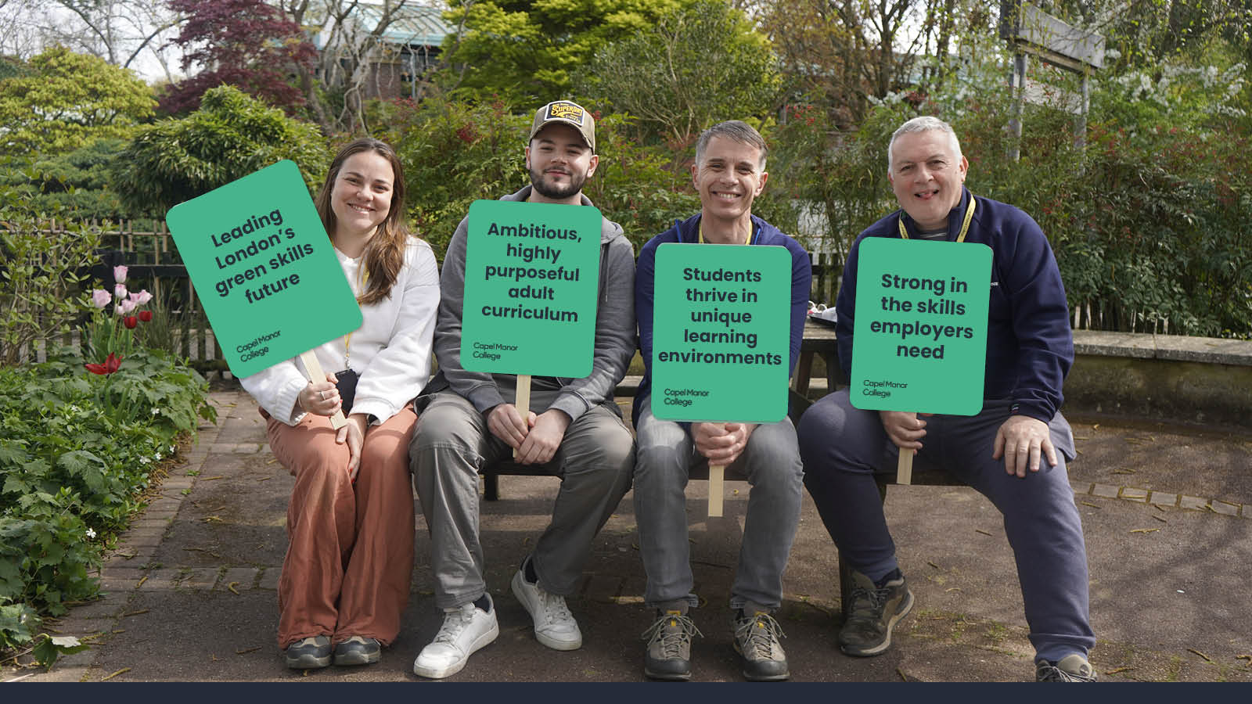

- Corporation Statement

On behalf of the Capel Manor College Corporation, it is hereby confirmed that the Corporation conducts reviews in line with the local needs duty, as such resulting in this plan. The annual accountability statement sets out an agreed statement of purpose, aims and objectives as approved by the corporation on 15/07/2026. The plan will be published on the College’s website within three months of the start of the new academic year.

Joanne Roxburgh Peter Brammall
Chair of Corporation Principal/Chief Executive
and Accounting Officer

Dated: 16 July 2026

Appendix i: The EIF Standards for the Contribution to Skills Needs
The EIF Standards for the Contribution to Skills Needs
Expected Standard | - Leaders engage effectively with employers and stakeholders to understand local, regional, and national skills priorities.  - Curriculum planning reflects identified workforce needs.  - Employers and stakeholders contribute to curriculum planning, work experience, and placements.  - Learners and apprentices benefit from stakeholder expertise and develop relevant skills for employment, training, further study, and independence.  - Skills-related curriculum content is generally planned and taught well at subject level.
Strong Standard | - Leaders engage widely and consistently with employers and stakeholders and demonstrate a thorough understanding of skills priorities.  - Labour market intelligence informs curriculum planning and curriculum development.  - Employers contribute meaningfully to subject-level curriculum design and delivery.  - Strong and sustained partnerships support curriculum responsiveness and workforce development.  - Learners and apprentices develop extensive technical skills, knowledge, and professional behaviours through industry engagement and high-quality curriculum experiences.  - Data demonstrates measurable impact on learner progression, employment, apprenticeships, and skills development.
Exceptional Standard | - Leaders spearhead highly beneficial and sustained partnerships that make a significant contribution to local, regional, and national skills priorities.  - At subject level, skills-related curriculum content is planned expertly and taught highly effectively across curriculum areas.  - Employers are fully embedded within curriculum design, workforce planning, and industry practice.  - Learners and apprentices develop a wide range of technical skills, knowledge, and professional behaviours exceptionally well, preparing them for employment, independence, further training, and future study.  - Sustained and measurable evidence demonstrates the long-term impact of partnerships and curriculum innovation on learner outcomes and workforce development.  - Leaders actively contribute to wider sector improvement through collaboration, professional networks, and the sharing of effective practice across the further education and skills sector.  - There are no significant areas for development that leaders have not already identified and prioritised through strategic planning and quality improvement activity.

Appendix ii: Capel Manor College - Current Position 2025-26
Engagement | Strategic Examples | Impact Evidence and Case Studies | Status
Civic Engagement  (Local authorities, GLA, DfE) | Conservation and Biodiversity Projects. Delivering rewilding, conservation grazing, and biodiversity restoration across London boroughs (e.g., Enfield, Bromley, Ealing, Greenwich, Camden). Learners and staff work alongside local authorities, conservation charities, and community groups, contributing to improved biodiversity, green space management, and public access.  Therapeutic Horticulture and Community Wellbeing. Providing therapeutic horticulture projects for vulnerable groups, including those with mental health needs, through partnerships with borough councils and community organisations. Supporting improved wellbeing and mental health outcomes by creating inclusive, accessible green spaces.  Partnership with Enfield Council – DBV Programme. Supporting the DfE Delivering Better Value (DBV) Programme to improve the quality and financial sustainability of SEND services. Working directly with Enfield Council teams to connect education, employer partnerships, and local authority services improving outcomes for learners with additional needs.  Green Economy Skills Development. Founding member of the Mayor’s Green Skills Academies and key partner in Green Skills Hubs across London, aligning skills delivery to civic priorities like the Net Zero Strategy, biodiversity action plans, and social mobility objectives.  Civic-Led Learning Projects. Engaging learners in live civic projects (e.g., conservation work, school outreach, rewilding sites) that contribute to public good while building employability skills. Partnering with local boroughs on projects that support inclusive access to green spaces, therapeutic learning, and public engagement.  Community Events and Skills Outreach. Hosting and participating in events such as open days, green skills showcase, and community learning festivals that promote lifelong learning and civic pride. Offering free breakfast clubs, food banks, and digital access support to ensure learners from disadvantaged backgrounds can participate fully in education. | These examples demonstrate how Capel Manor’s civic engagement translates into tangible outcomes for London’s communities, supporting the city’s transition to a greener, fairer future  Conservation and Biodiversity Projects -please see the Employer Engagement Action Plan  - Number of green spaces restored, biodiversity sites supported, and hectares of land managed (e.g., 150 acres across 5 boroughs)  - Number of learners participating in conservation projects (e.g., 300+ annually)  - Number of species reintroduced or supported (e.g., beaver reintroduction in Enfield)  - Borough and community partner feedback on environmental improvements  - Case studies of improved public access and community use of green spaces  - Number of SEND learners supported through DBV-aligned pathways (e.g., 50+ learners engaged)  - Learner progression rates (e.g., 70%+ progressing into further learning or employment)  - Borough feedback on partnership impact (e.g., Enfield Council case study, improved SEND outcomes)  - Contribution to DfE SEND targets (e.g., improved financial sustainability of services)  - Number of learners on green skills pathways (e.g., 3,000+ learners annually)  - Employer satisfaction survey results (e.g., 85%+ satisfaction with learner readiness)  - Progression into green economy careers (e.g., 90%+ positive destinations)  - Number of learners accessing employer-led projects (e.g., 1,200+ per year)  - Contributions to London-wide initiatives (e.g., lead role in Mayor’s Green Skills Academies)  Civic-Led Learning Projects  - Number of live civic projects embedded in curriculum (e.g., 30+ per year)  - Learner engagement data (e.g., % of students involved in civic projects)  - Public feedback from community events or civic project beneficiaries  - Learner reflection data capturing skills and confidence gained  - Number of community events hosted or attended (e.g., 10+ events annually)  - Number of participants engaged (e.g., 500+ attendees at green skills showcase)  - Feedback from event participants (e.g., 90%+ reporting increased awareness of green skills)  - Impact stories e.g., learners recruited via events, community partnerships strengthened | STRONG Standard
Community Engagement  (Charities, community groups, third sector) | Capel Manor College works in partnership with a wide range of national and local charities to deliver community-focused, place-based education that supports environmental sustainability, social wellbeing, and civic participation.  Key partners include:  - Groundwork  - Parks for London  - London Wildlife Trust  - The Conservation Volunteers (TCV)  - Thrive (therapeutic horticulture)  - Local mental health and wellbeing charities (e.g., Mind)  Capel delivers over 30 civic and community projects annually, creating direct impact through:  - Rewilding and habitat restoration projects  - Community gardens and biodiversity sites  - Conservation grazing initiatives  - Therapeutic horticulture programmes  We collaborate closely with borough councils across Enfield, Bromley, Ealing, Greenwich, and Camden to support environmental regeneration and community wellbeing, including:  - Conservation grazing projects, rewilding plans, and the reintroduction of beavers as part of Enfield’s flood prevention strategy.  - Management of the 180-acre Forty Hall Farm in partnership with Enfield Council, including community volunteering opportunities in the orchard, vineyard, and the Enfield Veg Box Scheme a market garden supporting both learner education and fresh food access for local residents.  - Tree management and biodiversity projects at Gunnersbury Park (Ealing) and Mottingham (Bromley).  - The Hiroshima Seed Initiative with Lewisham Borough Council connecting global sustainability goals to local action.  - Community-supported agriculture initiatives such as the Enfield Veg Box Scheme.  Capel’s community engagement also includes:  - Partnerships with local schools, SEND services, and community organisations to widen participation in land-based learning.  - Free community breakfast clubs and food banks across campuses supporting local residents and students experiencing hardship.  - Learner participation in public events, community showcases, and volunteering initiatives developing employability skills while contributing to civic life. | - Number of civic projects delivered annually (30+)  - Number of learners engaged in civic projects and community volunteering  - Borough and community partner feedback (e.g., case studies, testimonials)  - Environmental metrics (e.g., hectares of land restored, species reintroduced)  - Wellbeing outcomes for community participants (e.g., feedback from therapeutic horticulture programmes)  - Number of families supported through community food programmes (e.g., Veg Box Scheme, food banks)  - Over 150 acres of green space managed, restored, or supported by Capel Manor learners across London.  - 100+ learners annually involved in community-based projects, contributing to environmental and social outcomes.  - 100+ community participants engaged in therapeutic horticulture and wellbeing projects per year, improving mental health and reducing social isolation.  - 100% of participants in therapeutic horticulture report improved wellbeing and reduced isolation (internal survey, 2024/25).  - 56% of 16–18 learners come from areas of social and economic deprivation.  - 32.7% of learners identify as from ethnic minority backgrounds (Landex 2023 sector benchmark: 25%).  - 24.2% of learners have SEND; over 200 High Needs learners supported annually.  - Engagement with learners from all 32 London boroughs, demonstrating inclusive access across the capital.  - Community projects contributing to London’s Net Zero and biodiversity targets, supporting green skills pipelines and the Mayor’s Green Skills Strategy.  - Positive learner outcomes: Over 90% of learners progress to employment, further study, or apprenticeships in green sectors.  - Bromley Council, advises on the onsite maintenance and enhancement of woodland surrounding the College campus at Mottingham; working with local councillors to engage with schools around NEET prevention and contributions to maintenance works at Crystal Palace Park, within which another College campus is situated;  - Job Centre Plus, running employability workshops and re-engagement provision targeting those unemployed/seeking new work avenues. | STRONG Standard
Education Engagement  (Schools, other colleges, HEI’s) | Capel Manor College plays a key role in London’s education system, working across schools, further education providers, higher education institutions, and industry to develop progression pathways into green skills and land-based careers.  Schools Partnerships  - Hosting the Enfield Schools Forum and Secondary Heads meeting at Capel, ensuring FE representation and fostering strong links with secondary schools.  - Delivering bespoke Year 10 and Year 11 green skills taster sessions to promote early engagement with land-based and environmental sectors.  - Collaborating with schools on NEET prevention initiatives and targeted support for vulnerable learners, including those with SEND and at risk of disengagement.  - Working with Enfield Council and schools to co-create Supported Internship programmes for learners with additional needs.  - Supporting Lewisham’s Hiroshima Seed Initiative, embedding global sustainability into local learning.  FE and College Partnerships  - A founding member of the Mayor’s Green Skills Academies, co-developing sector-specific skills frameworks and sharing best practice with FE partners.  - A key partner in the Local Skills Improvement Fund (LSIF) collaboration, one of the largest in the country, with 23 delivery partners across London.  - Sharing expertise through communities of practice, including the SEND Centre of Excellence peer review and joint curriculum development with colleges such as Sparsholt College.  - Participating in sector-wide networks, including the British Association of Landscape Industries, Society of Garden Designers, and the Association of Professional Landscapers.  Higher Education Institutions  - Partnering with the Royal Agricultural University (RAU) to deliver higher education programmes in Animal Management and exploring joint delivery of degrees in Environmental Science and Urban Green Space Management.  - Contributing to HE pathways in green infrastructure, biodiversity, and sustainable urban design through employer-informed curriculum development.  Additional Strategic Engagement  - Working with the Worshipful Livery Companies, ensuring Capel’s specialist curriculum in Saddlery and Leathercraft meets industry standards and benefits from royal patronage.  - Developing progression routes from Level 1 to Higher Technical Qualifications (HTQs) in green skills priority sectors, aligned with government skills policy. | Through these collaborative partnerships, Capel Manor College ensures learners access a connected, progression-focused education system from school engagement to higher-level qualifications developing the green skills, knowledge, and behaviours needed for London’s sustainable future.  Over 400 school pupils engaged annually through bespoke Year 10–11 taster sessions in green careers, animal care, floristry, and horticulture.  - NEET prevention and SEND engagement programmes delivered in partnership with borough councils and secondary schools.  - Capel’s supported internship pathway developed with Enfield Council and local SEND schools, leading to over 70% sustained outcomes for learners with EHCPs in 2023/24.  - Increased conversion from taster events to full-time study, particularly in horticulture and animal management (20% increase YoY).  FE and College Partnerships  - Capel is a founding member of the Mayor’s Green Skills Academies and an anchor provider in one of England’s largest LSIF-funded partnerships (23 delivery organisations).  - Co-designed curriculum pathways now being shared across LSIF partners, with early outcomes showing improved learner retention and curriculum alignment.  - Participation in the SEND Centre of Excellence has led to Capel’s revised SEND strategy, now embedding trauma-informed and inclusive practice across all schools.  - Cross-college curriculum benchmarking with Sparsholt College and City of Norwich College, supporting consistency in land-based skills delivery  Higher Education Institutions  - Partnership with the Royal Agricultural University (RAU) supports the delivery of L4+ Animal Management programmes, with over 85% progression into employment or further HE studies.  - Capel’s HE ambitions are growing, with curriculum development underway in Environmental Science and Urban Green Space Management, co-designed with employers to align with future green job growth.  - First-time HE students from underrepresented backgrounds make up over 50% of Capel’s L4+ cohort—supporting key civic mission and access goals. | STRONG Standard
Employer engagement  e.g. Frances Roche (Master Harness Maker)  Bill Bird (Bespoke Shoemaker) | Capel Manor College’s Employer Framework provides a systematic approach to employer engagement, capturing industry insights and shaping provision through over 200 active partnerships. These partnerships inform curriculum design, influence skill priorities, and ensure learners gain the knowledge, behaviours, and confidence needed for success. Capel’s employer network spans a diverse range of sectors, including:  - Horticulture  - Arboriculture  - Conservation  - Animal care  - Floristry  - Saddlery  - Environmental management  These partnerships provide learners with access to live briefs, work placements, and real-world projects—bridging the gap between education and industry. Key employers shaping and influencing curriculum design include:  - Groundwork  - Parks for London  - The Royal Parks  - Kew Gardens  - Idverde  - Bartlett Tree Experts  - The Blue Cross  Capel’s employer engagement also extends to local authorities, delivering projects such as conservation grazing, rewilding, and biodiversity initiatives in partnership with Enfield, Bromley, and Ealing Councils—embedding sustainability goals into local communities and enhancing green spaces for public benefit.  This collaborative model ensures Capel Manor’s curriculum is aligned with current and emerging industry standards, creating a pipeline of talent that meets the evolving needs of London’s green economy. | Capel Manor College maintains over 200 active employer partnerships across the land-based and green skills sectors, ensuring the curriculum is co-designed, industry-informed, and aligned with emerging workforce needs.  Key partnerships include:  - Groundwork, Parks for London, The Royal Parks, Kew Gardens, Buckingham Palace, The Blue Cross, Bartlett Tree Experts, and a wide range of SMEs.  Employers shape curriculum content, deliver live briefs and projects, host site visits, and provide real-world technical insights—ensuring learners are equipped with the skills, behaviours, and confidence to thrive in a rapidly evolving green economy.  - Highlights include:  idverde: Co-developing curriculum, staff CPD, and talent pipelines.  - Groundwork: Biodiversity net gain and nature recovery projects with practical student placements.  - The Blue Cross & Royal Veterinary College: Shaping the Animal Management curriculum to meet industry standards in welfare and behaviour.  - Bartlett Tree Experts: Delivering technical tree health demonstrations to support arboriculture careers.  - Lea Valley, Essex & Suffolk Wildlife Trusts, Natural England, Canals & River Trust: Providing conservation and biodiversity project opportunities.  - Anna’s Flower Farm & Immediate Media: Industry-led briefs for floristry and event planning, including live client projects like the Radio Times Cover Party at Claridges.  - Genuit Group: Raising sector awareness of future biodiversity skills gaps, with site visits, CPD, and a green infrastructure showcase unit.  Sorbus International: Specialist arboriculture equipment demonstrations, supporting technical knowledge and industry understanding.  Capel’s Employer Framework includes:  - 200+ employer engagement encounters annually  - 100+ employers on advisory panels  - 1,200 learners accessing employer-led projects and briefs  - Employer satisfaction rates consistently above national benchmarks (exact % where available) | STRONG Standard

References & Relevant Document Links

1. Department for Education (2025) Skills England: Priorities and Strategic Direction 2025–2026. Outlines the Government’s emerging approach to national workforce planning, technical education reform, employer-led skills systems, and future workforce priorities across England, including green and technical skills development.

2. Department for Education (2025) Apprenticeship Funding Rules and Assessment Reforms 2025–2026. Provides updated guidance on apprenticeship delivery, assessment reform, employer responsiveness, and technical education pathways across further education and skills provision.

3. Skills and Post-16 Education Act (2022) UK Government Legislation.
Established the statutory framework for Local Skills Improvement Plans (LSIPs), strengthening employer influence within curriculum planning and post-16 technical education.

4. Greater London Authority (GLA) (2023) Mayor of London’s Green Skills Academy Mission. Sets out London’s strategic priorities for developing green skills pathways to support sustainability, net-zero ambitions, environmental resilience, and inclusive economic growth.

5. Local London Sub-Regional Partnership (2023) Accelerating Green Skills in London. Explores workforce shortages, green skills demand, and the role of further education providers in supporting London’s transition to a greener economy.

6. Department for Education (2025) Special Educational Needs and Disabilities (SEND) and Alternative Provision Improvement Plan: Progress Update.
Outlines national reforms designed to improve inclusion, learner support, progression pathways, and responsive provision across education and skills systems.

7. Association of Colleges (2024) Green Skills and the Role of Further Education Colleges. Highlights the critical role of FE colleges in supporting sustainability, local economic growth, employer partnerships, and workforce development within the green economy.

8. Quality Assurance Agency for Higher Education (QAA) (2023) Employer Engagement and Industry Collaboration in Higher Education and Technical Education.
Examines emerging practice in employer-informed curriculum design, industry partnerships, and progression pathways between further and higher education.

9. Pugh, S., & Grove, M. (2014) Establishing Industrial Advisory Boards Using a Practice Transfer Approach. Explores the role of employer advisory boards in aligning curriculum design with industry priorities and workforce needs.

10. Keep, E. & James Relly, S. (2023) Further Education and Skills Policy in England: Challenges and Future Directions. Analyses the evolving FE policy landscape, including employer responsiveness, technical education reform, local skills planning, and workforce development priorities.

11. Department for Education (2024) Local Skills Improvement Fund (LSIF): Strategic Guidance for Providers. Provides guidance on collaborative skills planning, innovation funding, employer engagement, and regional workforce development across FE partnerships.

12. Education and Training Foundation (ETF) (2024) Inclusive Teaching, Learning and Curriculum Design in Further Education. Explores effective approaches to inclusive curriculum development, learner engagement, and flexible technical education pathways

13. Capel Manor College Ofsted Report (January 2026 inspection) Inspection Report

14. London Local Skills Improvement Plan (2026 Update) 1. London LSIP Report (incl Annexes A-D).docx

